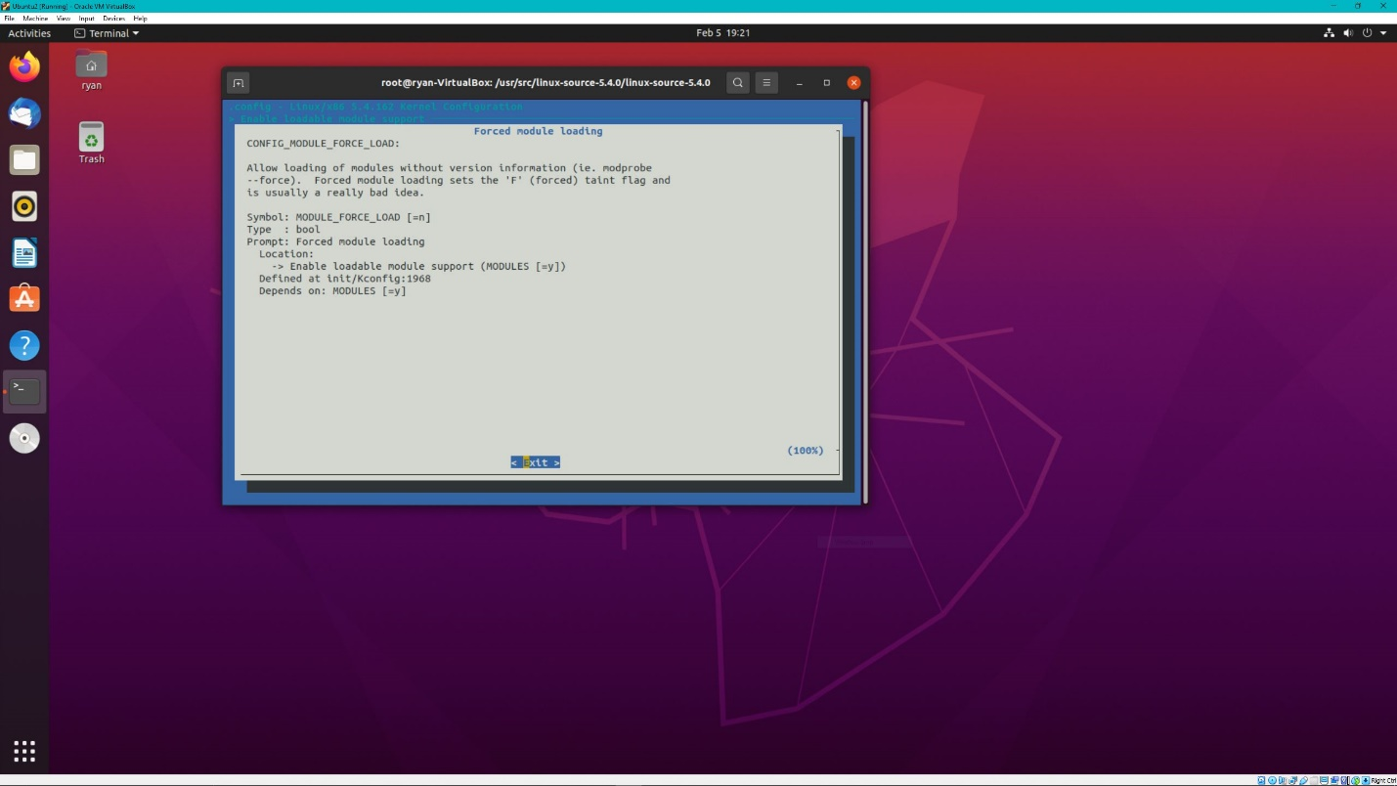

Forced module loading, keep on to be able to load the mp4 if there is an issue

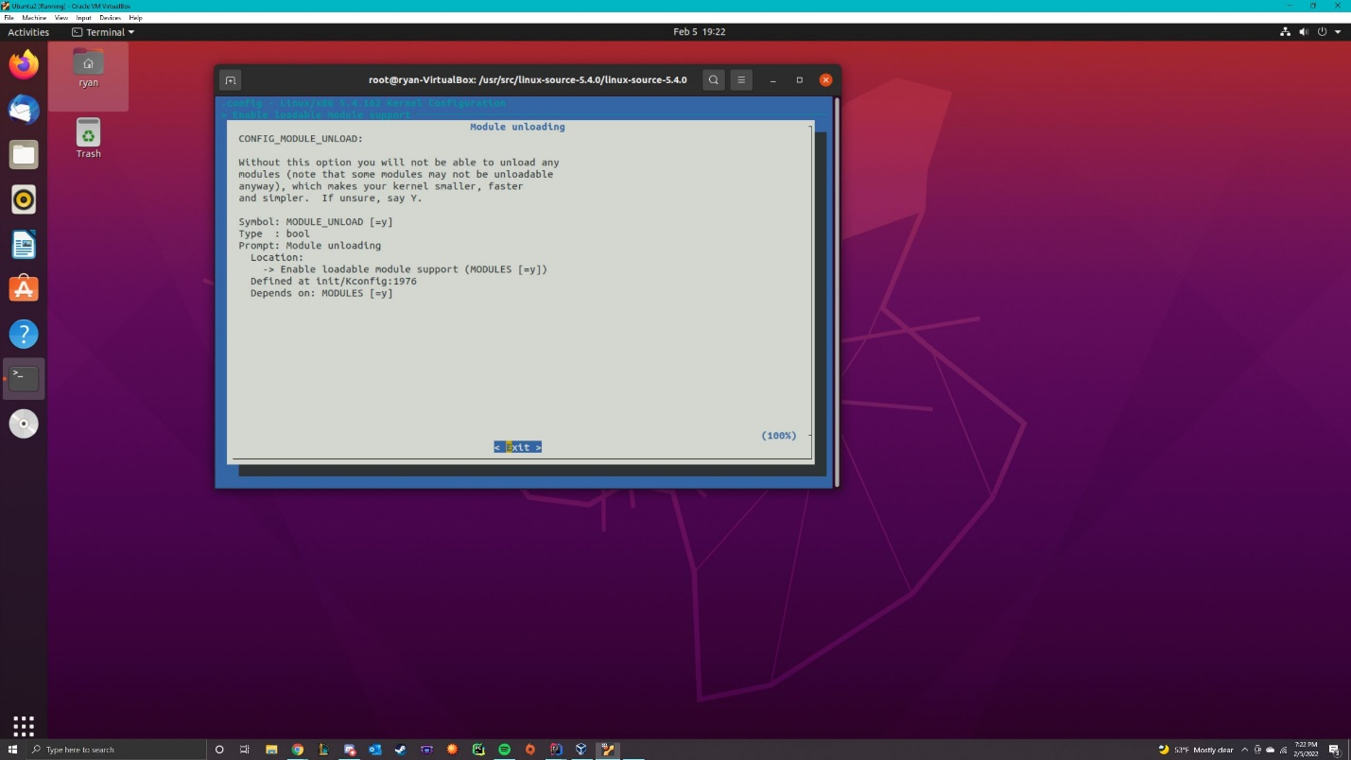

Module unloading, keep on for unloading the mp4 file

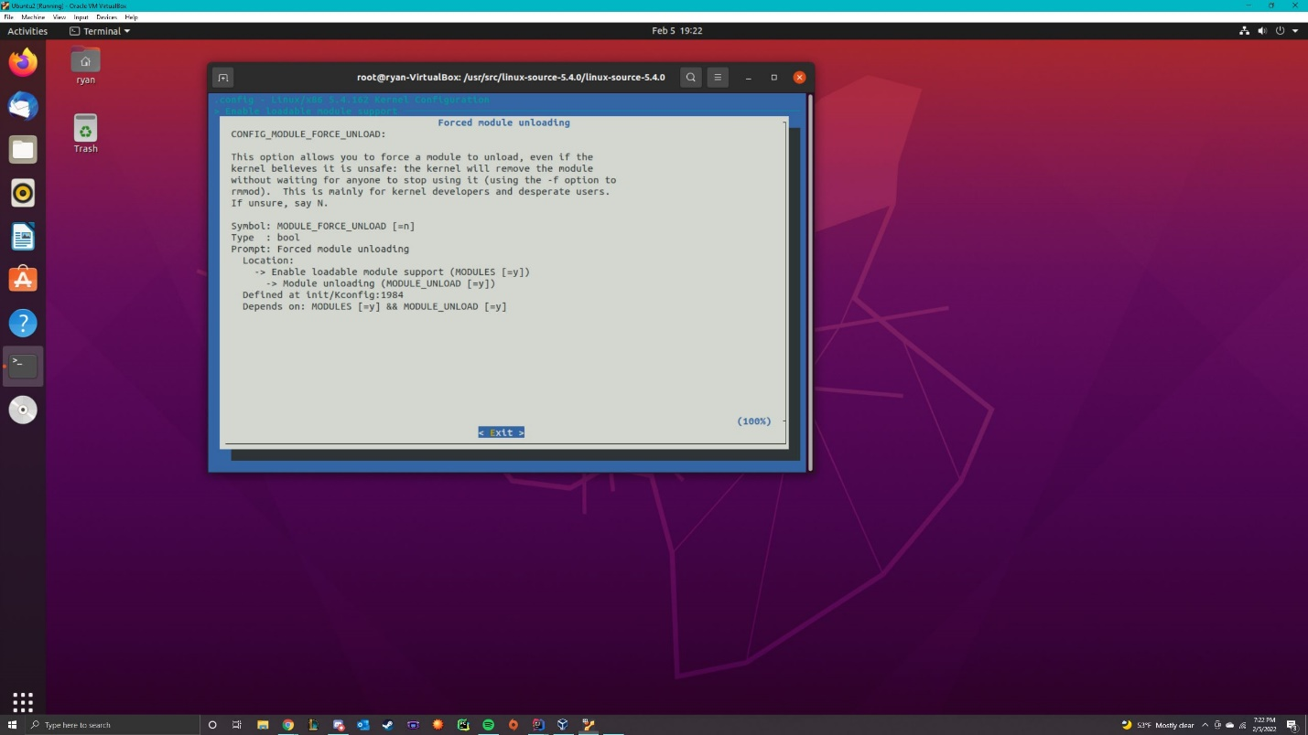

Forced module unloading, keep on if there is an issue with unloading the mp4

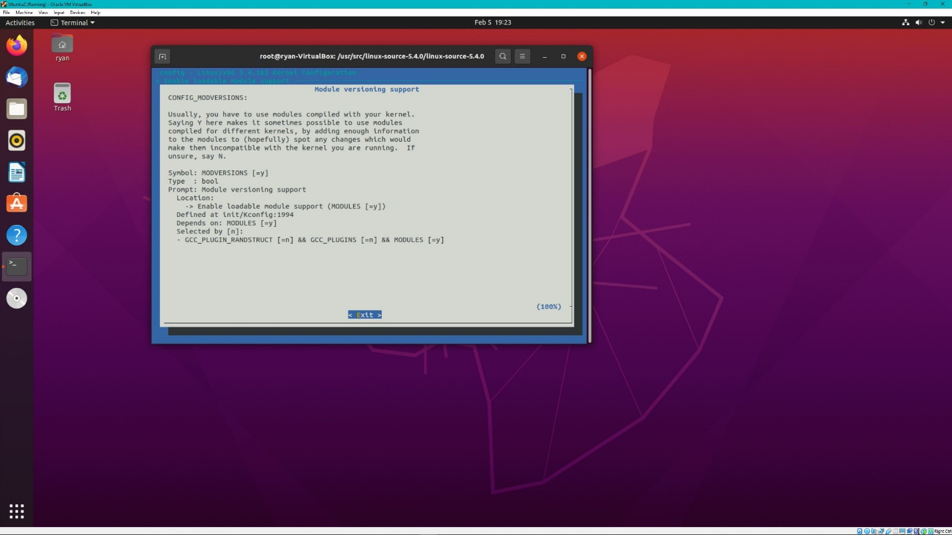

Module versioning support, keep on if there is an issue with the kernel and the mp4 file this will help us figure it out

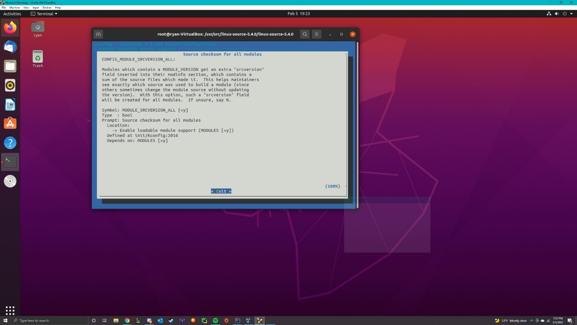

Source checksum for all modules, keep on to check for source version 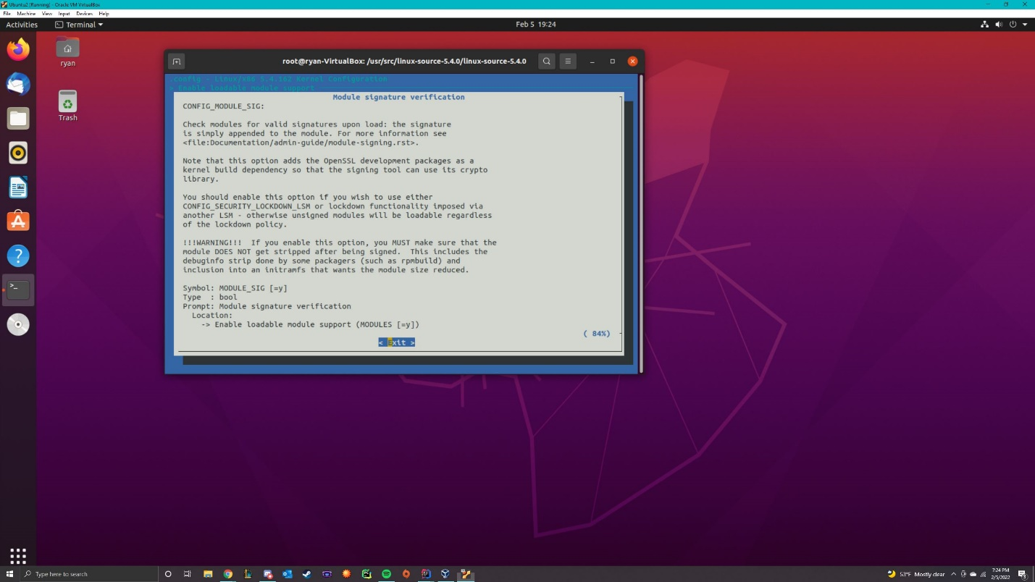

Module signature verification, keep on for checking the modules

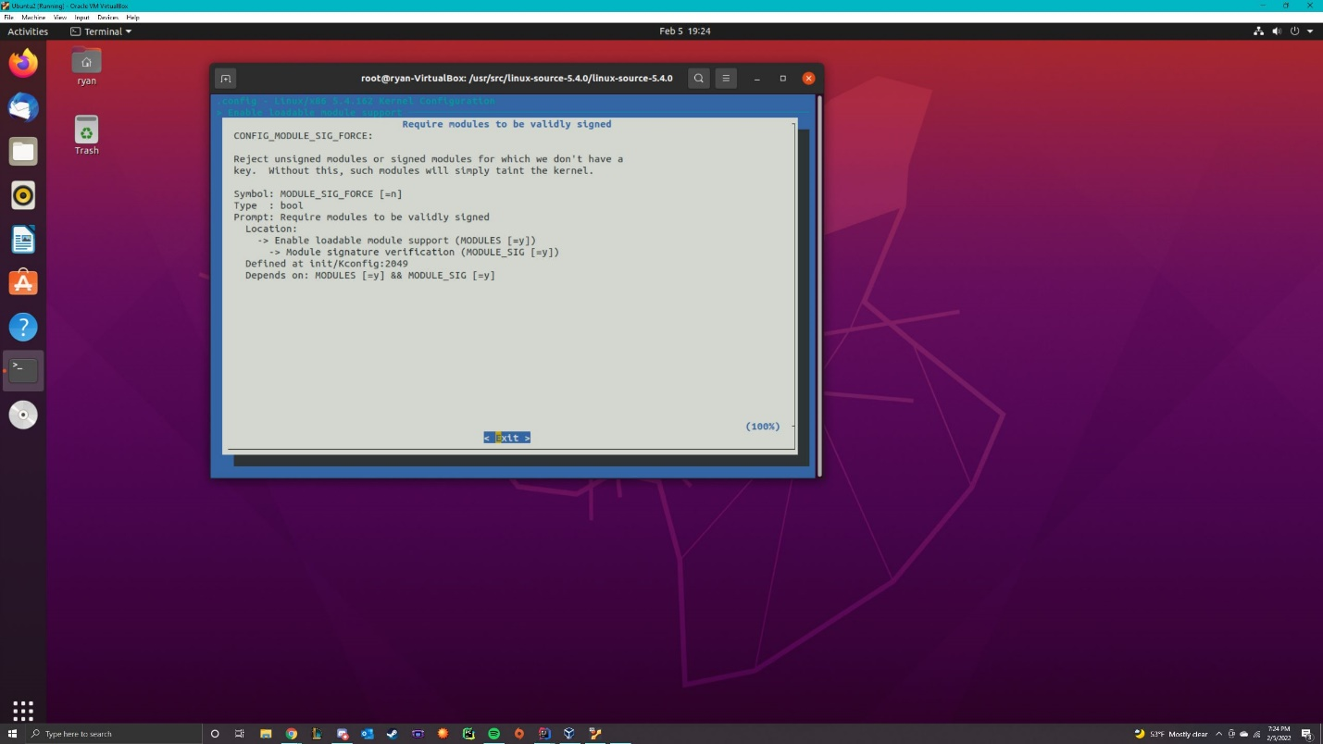

Require modules to be validly signed, keep on for checking verification of the mp4 file

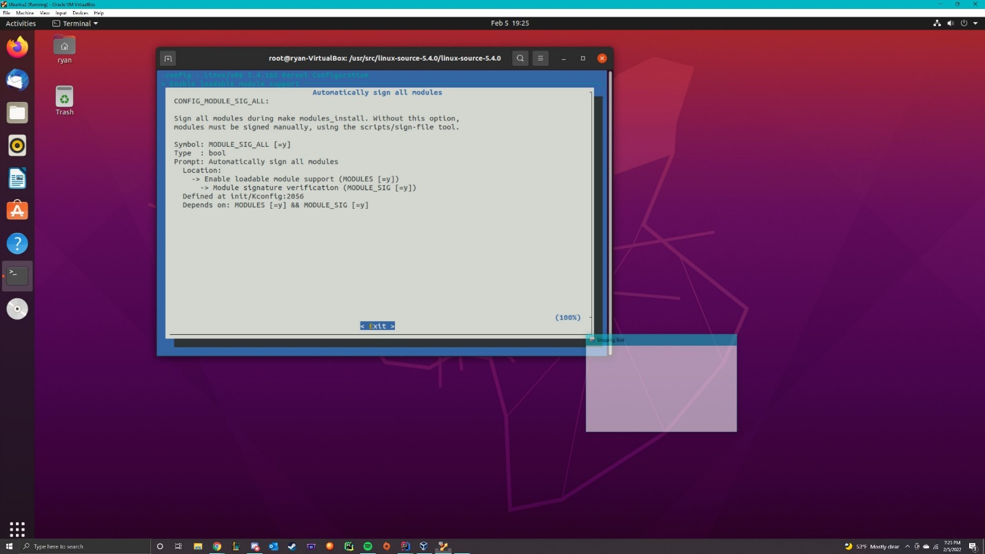

Automatically sign all modules, Keep on so you don’t have to sign on the file manually

The kernel configuration was very straightforward all I had to do was press Y(for yes) to customize it, and save it and then it worked.